**PRACTICAL 6**

**(Active Information Gathering)**

1. **DNS Enumeration**

Step 1: Open Kali Linux

Step 2: Click on Usual Applications >01-Information Gathering > DNS Analysis > dnsenum

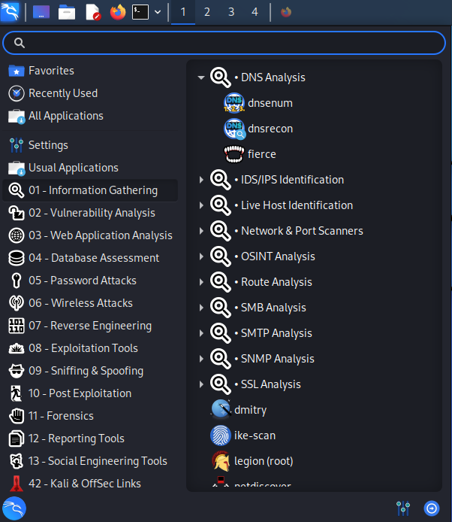

Step 3: Insert Command>dnsenum -h

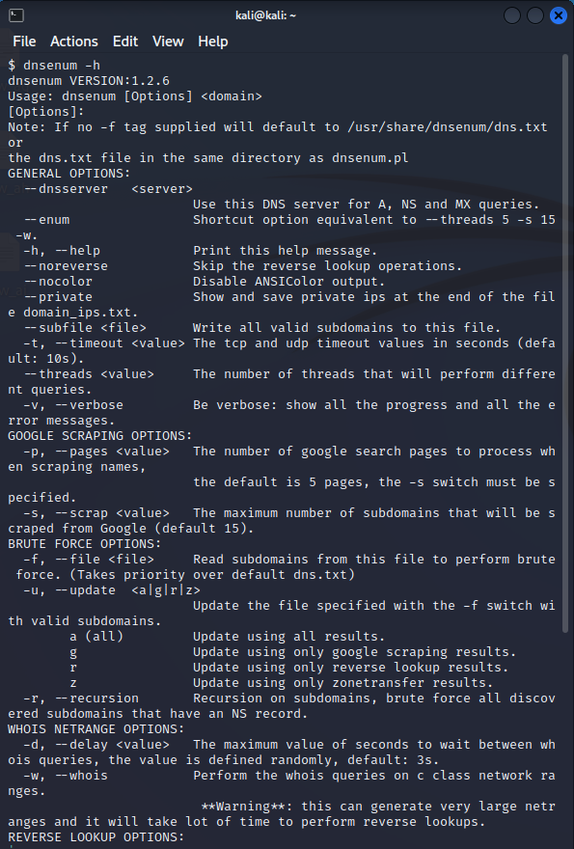

Step 4: Insert Command> dnsenum –dnsserver 8.8.8.8 twitter.com

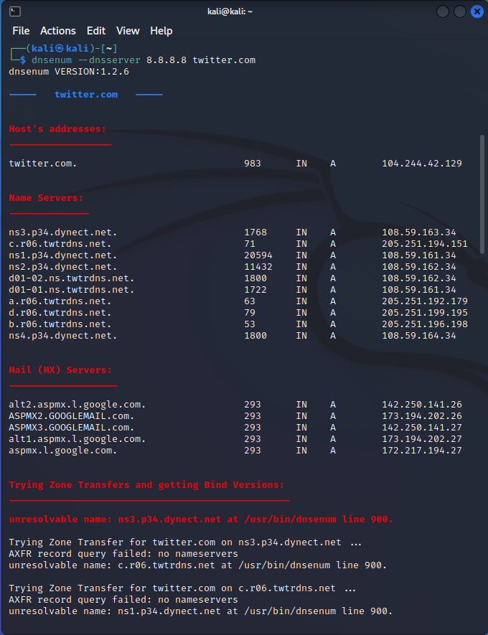

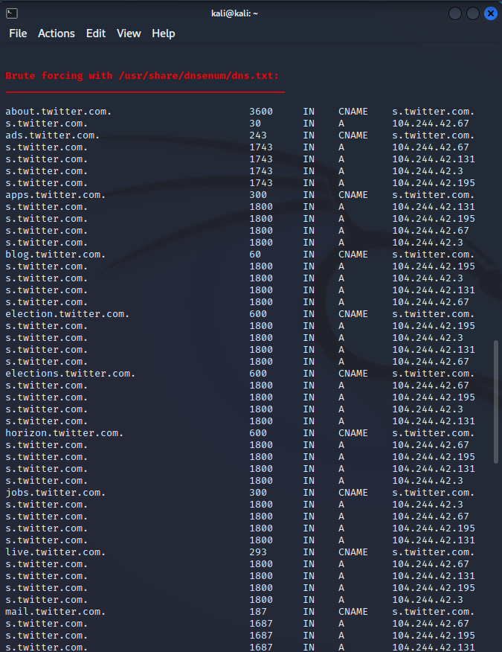

**PRACTICAL 7**

**(Vulnerability Scanning)**

1. **Vulnerability Scanning with Nessus**

Step 1: Search and Download Nessus for windows

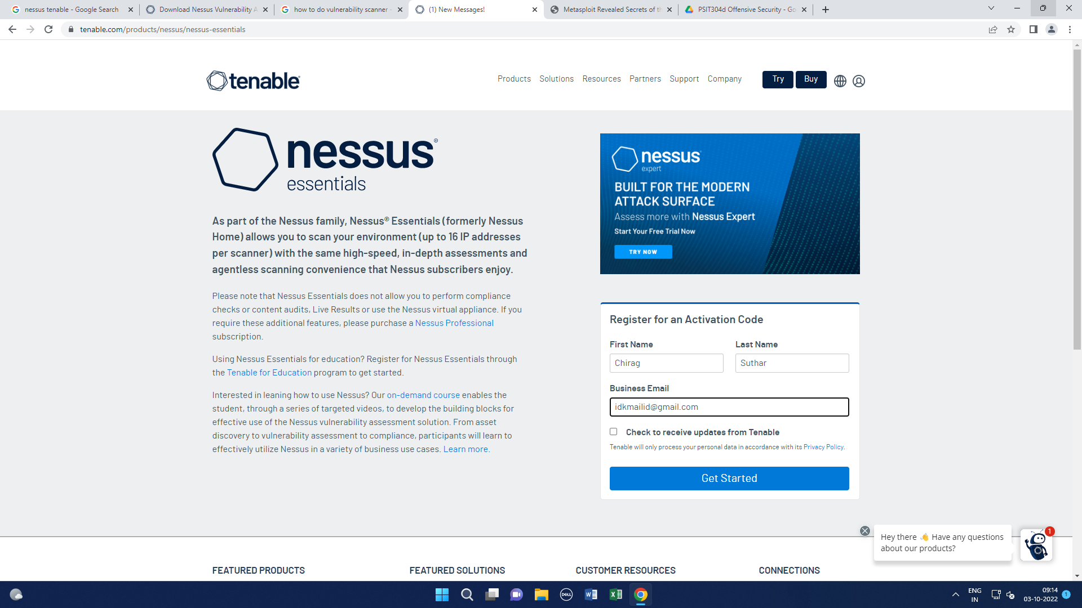



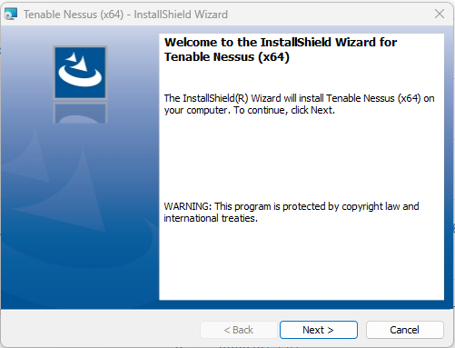

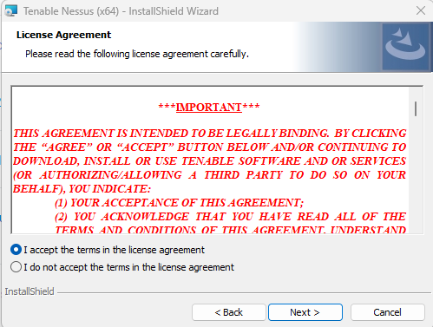 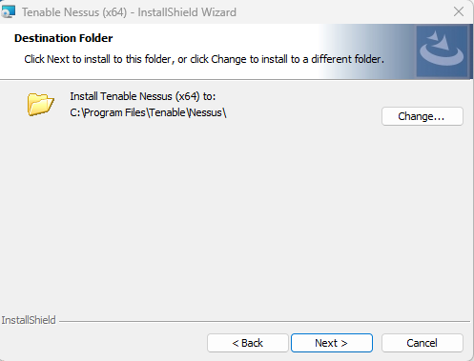

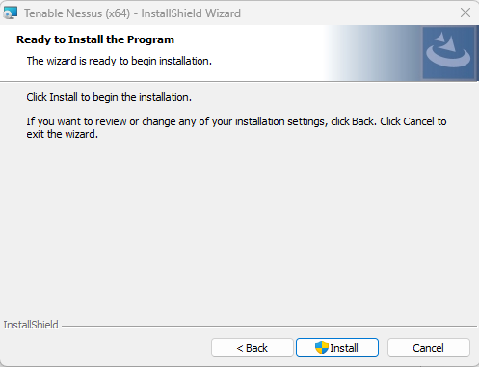 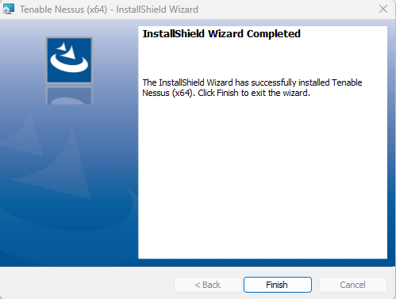

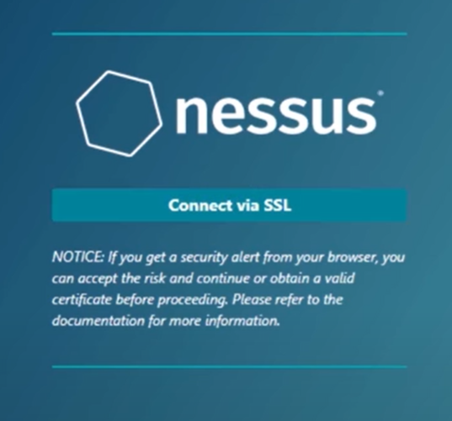 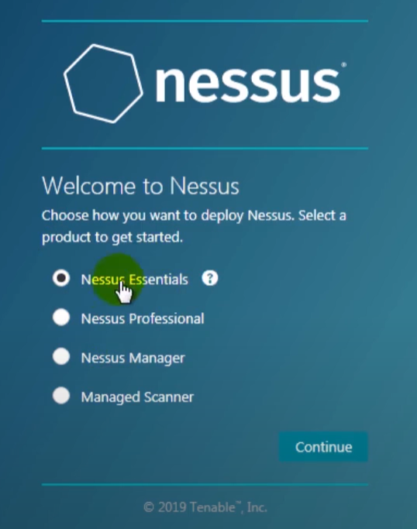

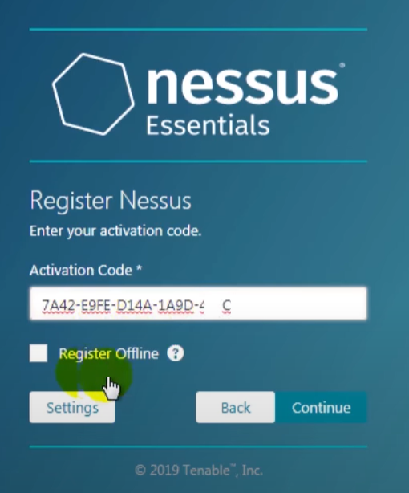

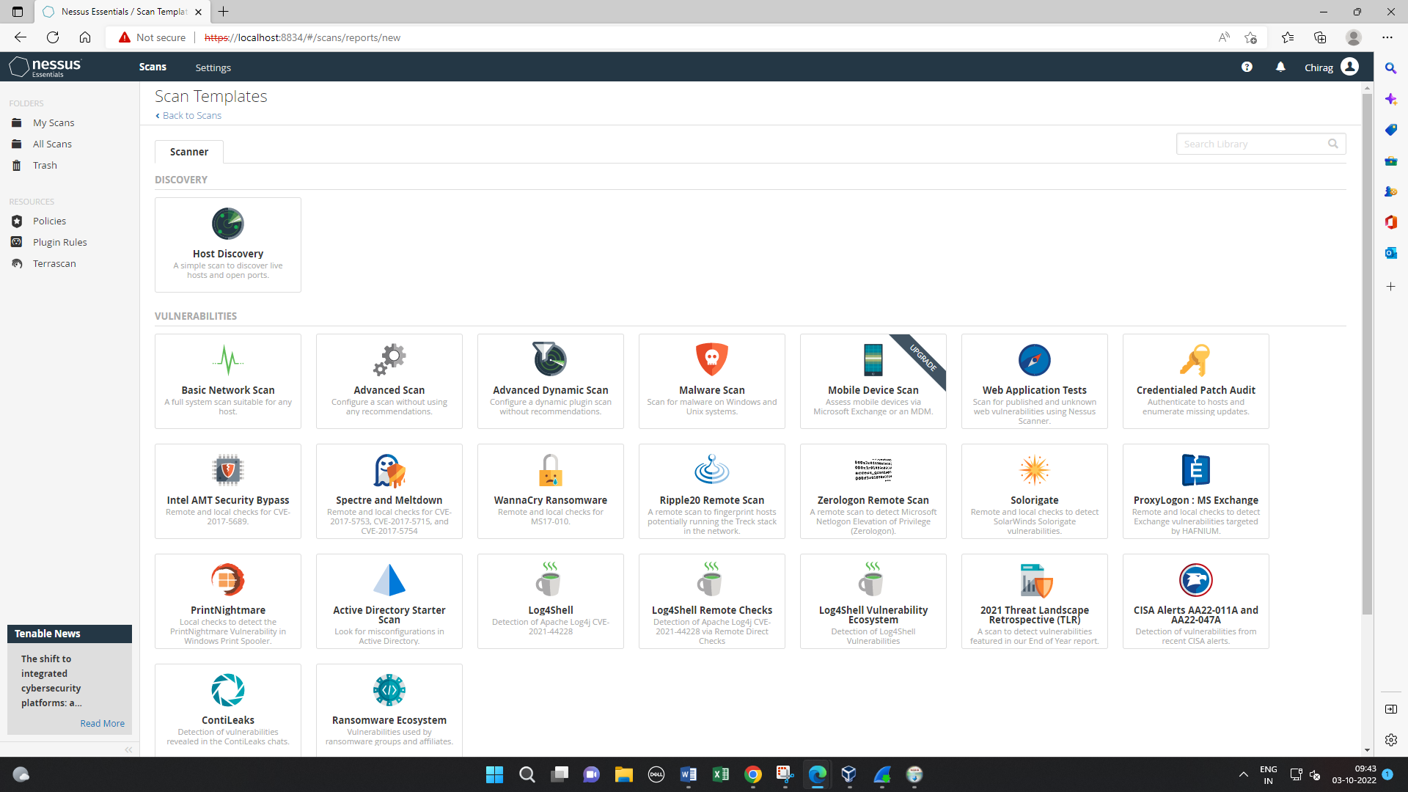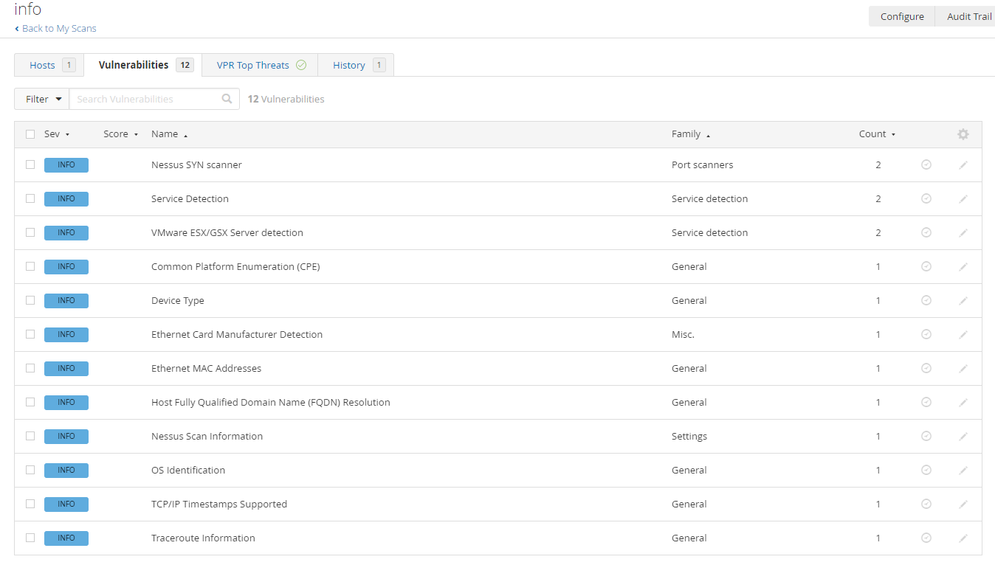

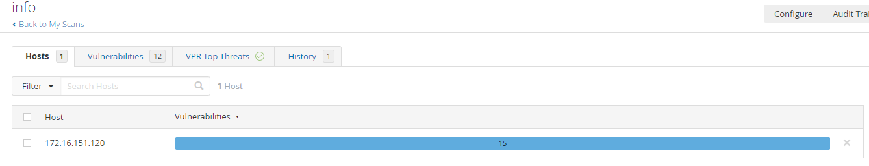

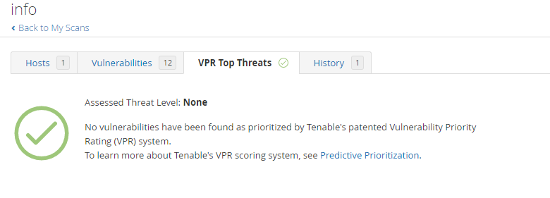

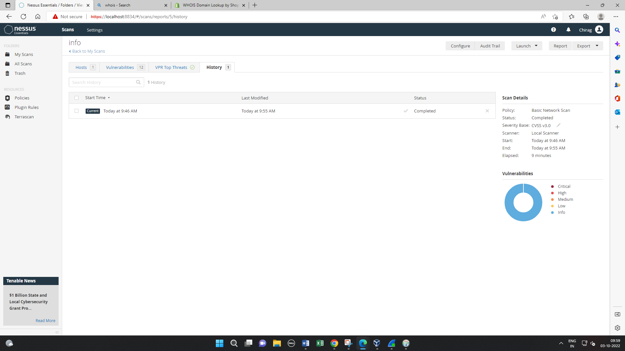

1. **Vulnerability Scanning with Nmap**

Step 1: Open Cmd

To trace the network or ports enter the trace Command with any website

Step 2: Insert Command> *C:\Users\Admin> tracert www.google.com*

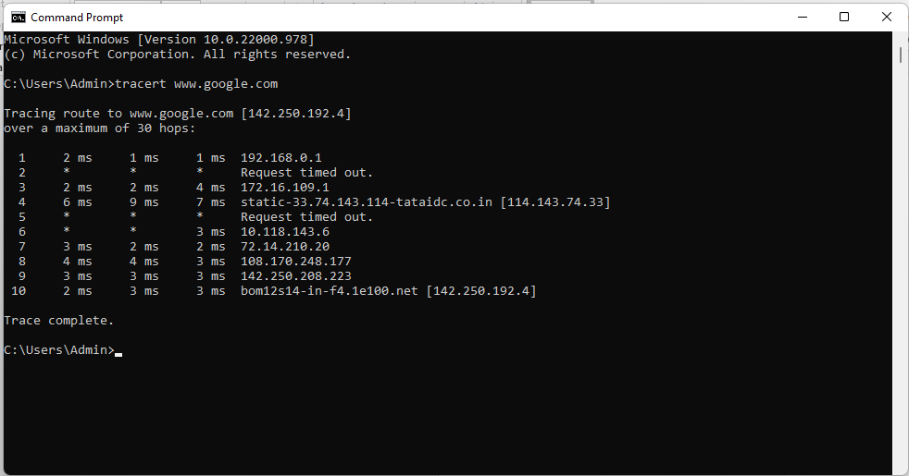

Step 3: Download and Install the Nmap

Step 4: Enter the IP Address on Nmap, in the Target profile tag select the intense scan. After this Step we will get Nmap Output.

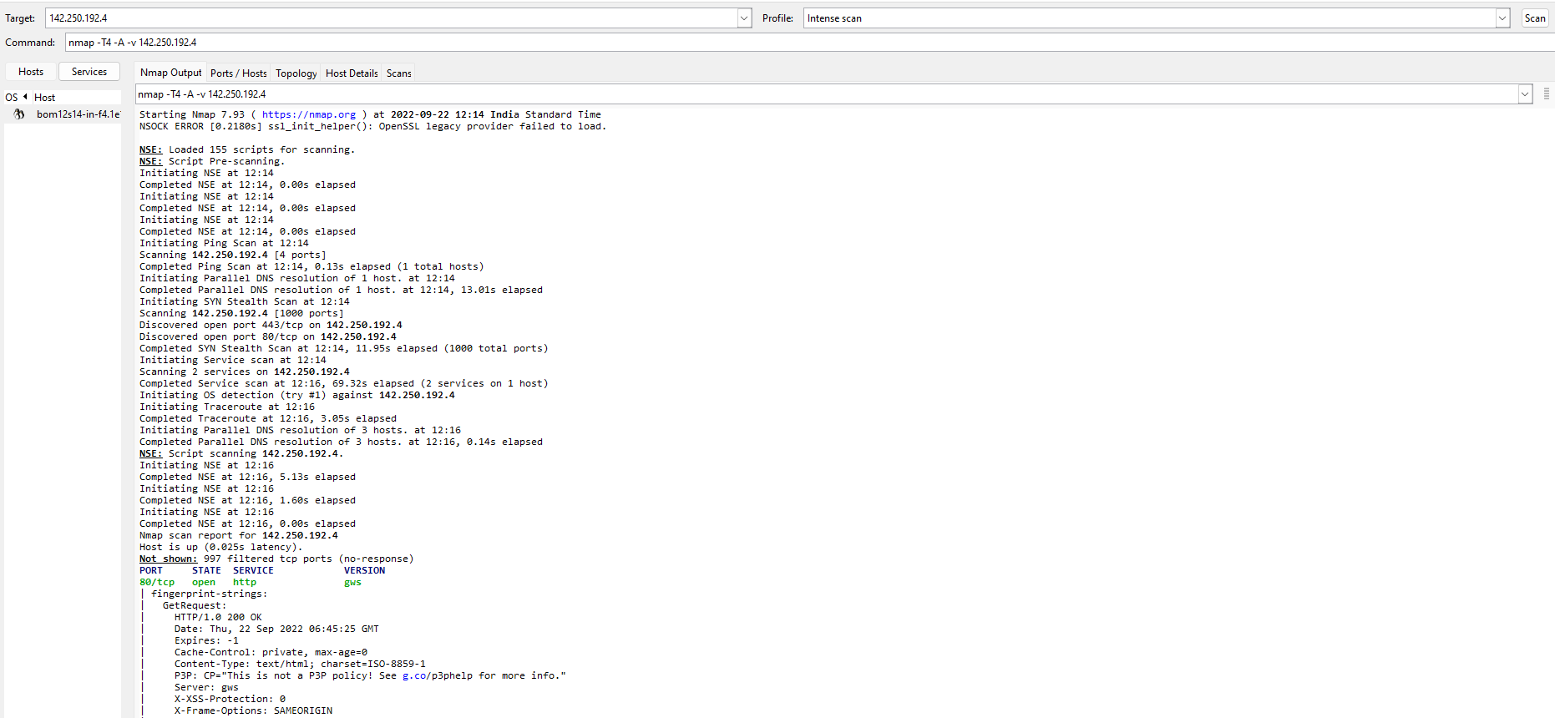

Step 5: Scanned and connected ports

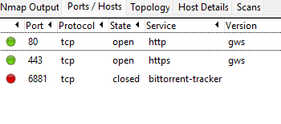

Step 6: Scanned and Connected Topology

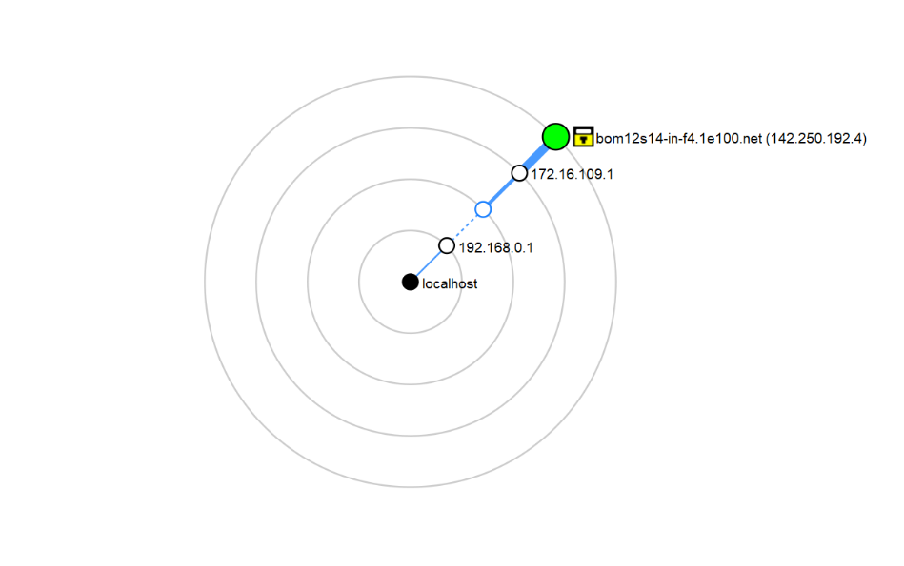

Step 7: Connected Host Details.

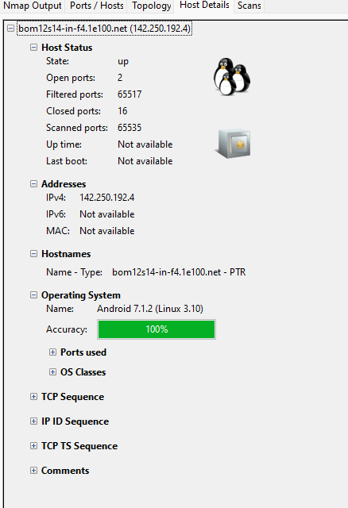

**PRACTICAL 8**

**(Web Application Assessment Tools)**

1. **DIRB**

Step 1: Download dirb tool from Mozilla firefox <https://www.secuneus.com/dirb-tool/>.

Step 2: Insert Command>dirb

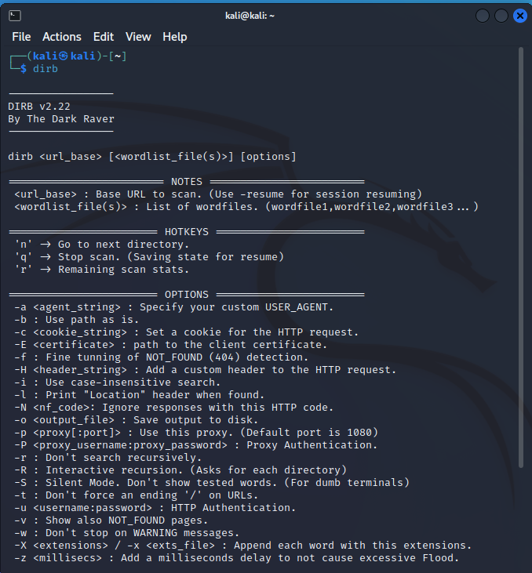

Step 3: Using **locate dirb** command take the path of wordlist from it:

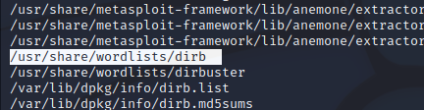

Step 4: Insert Command>ls -l -a

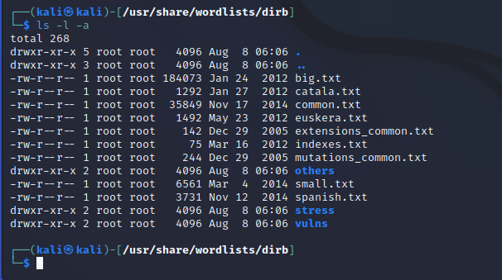

Step 5: Insert Command> cd vulns

Step 6: Insert Command> ls -l -a

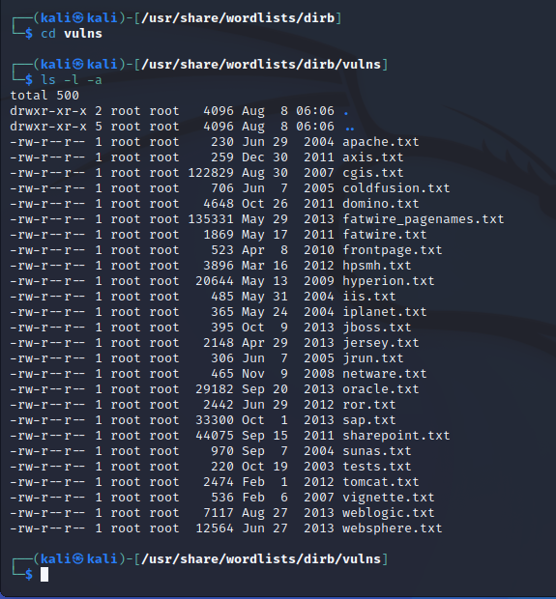

Step 7: Insert Command> dirb https://www.yahoo.com

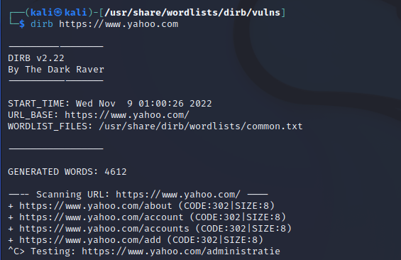

1. **Burp Suite**

Step 1: After downloading Burp Suite in guest machine. The first window comes is to login to Burp Suite Community Edition. Select your choice and click “Next” button.

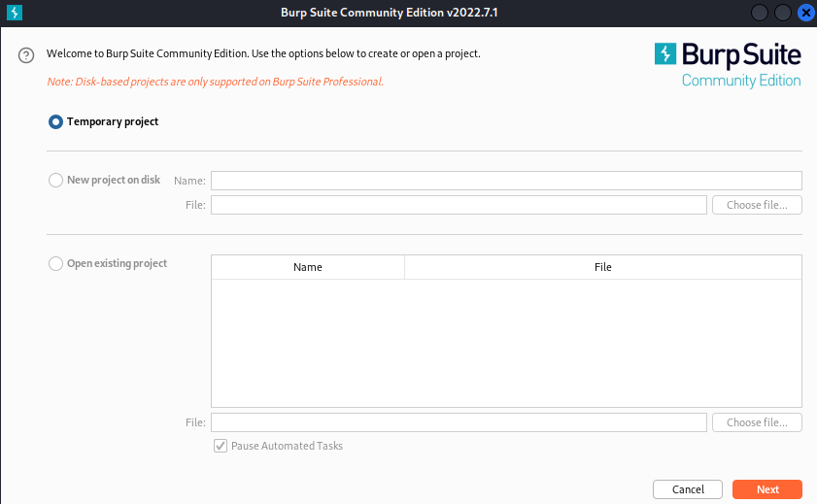

Step 2: Choose the required configuration and click on “Start Burp” button.

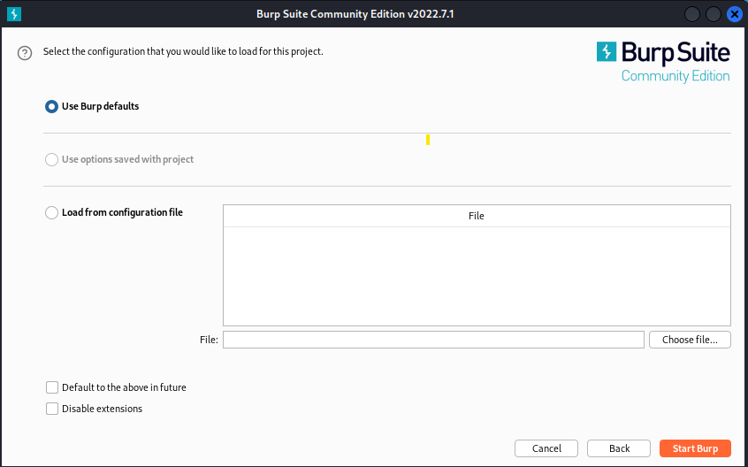

Step 3: The dashboard of Burp Suite will open to perform operation.

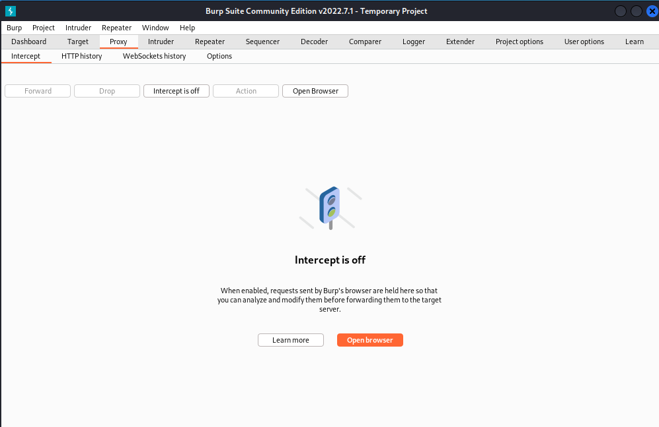

Step 4: Turn on Intercept by simply open browser .

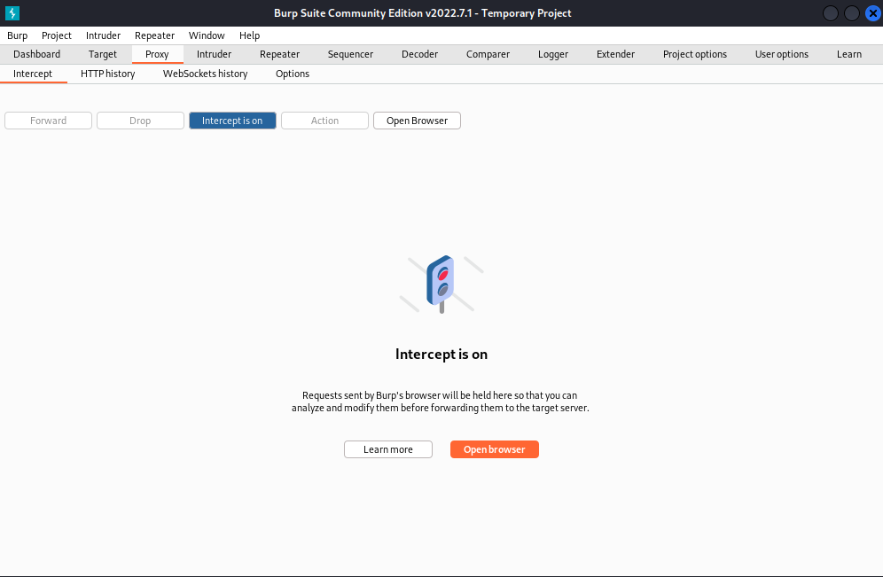

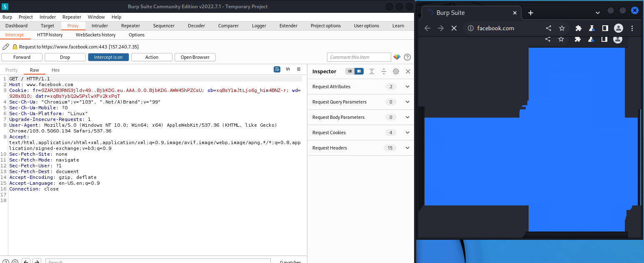

Step 5: Turn off the intercept after clicking on the forward twice/thrice:

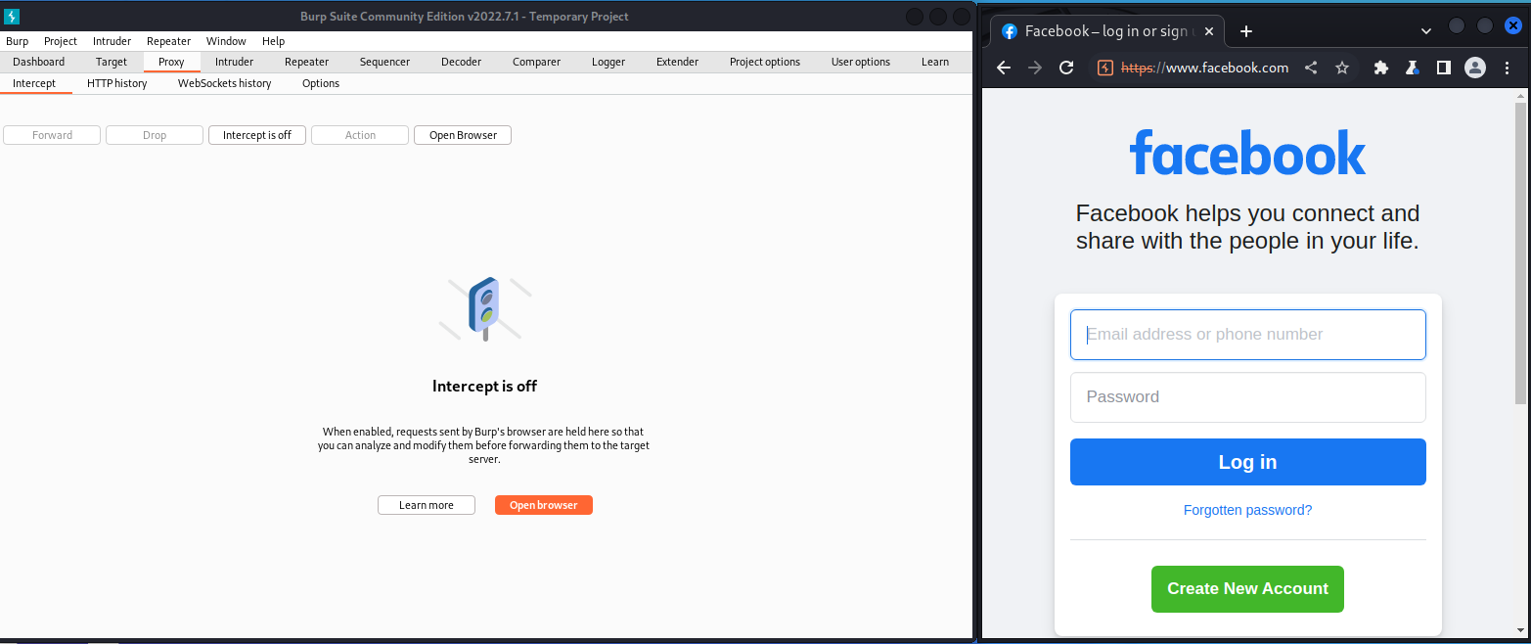

Step 6: See the HTTPhistory of host and by which Method.

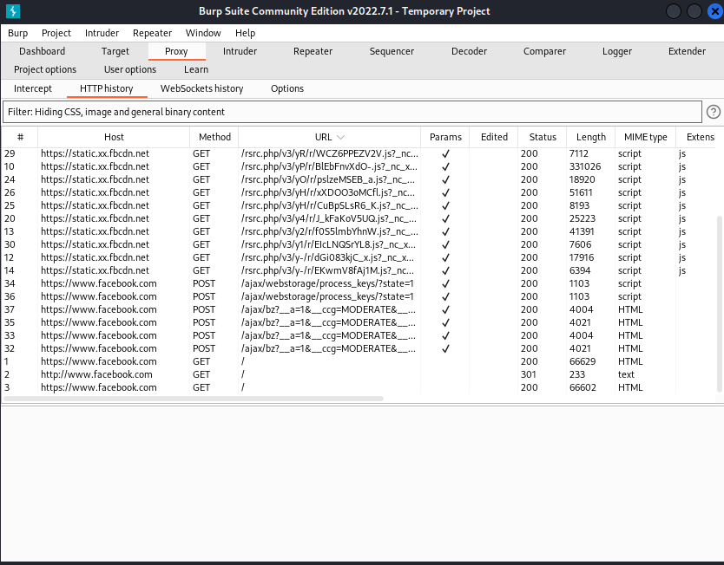

Step 7: Intruder feature allows user to automate attacks that send the same request many times, substituting specific values with predetermined payloads each time.

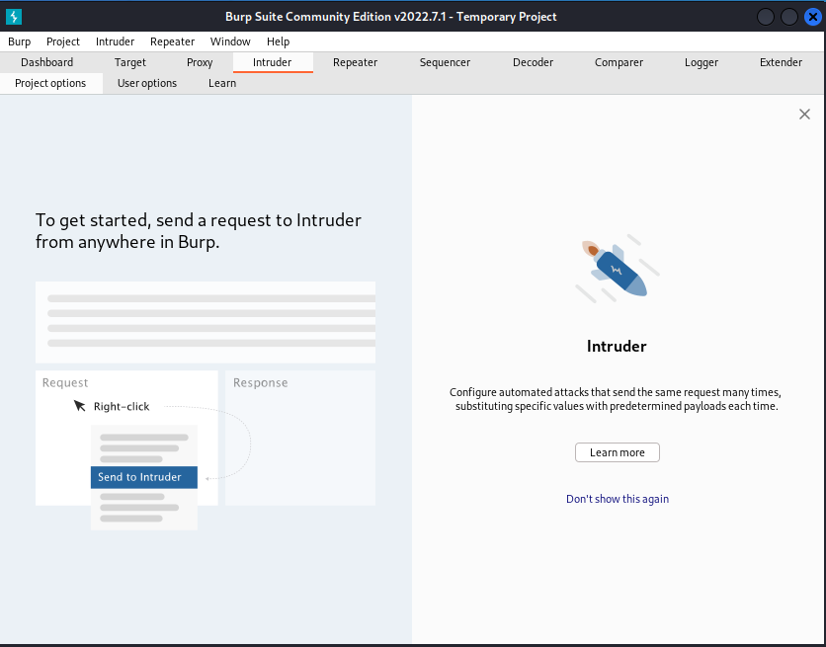

Step 8: We just turn all same request from a http server request to attackers by just right clicking on attackers side url and click on “Send to Intruder” or Ctrl+I.

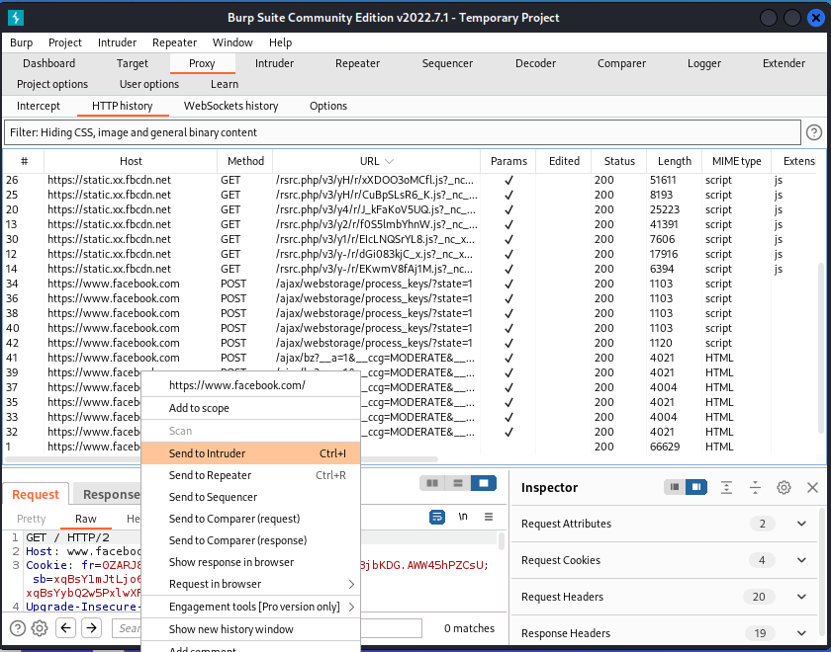

Step 9: We can select the “Attack Type:” and “Payload Positions “from specific URLs.

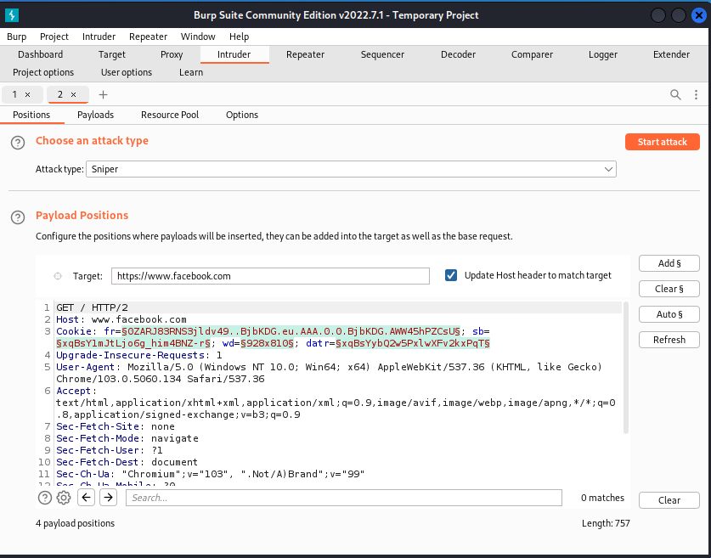

Step 10: Repeater allows to modify and resend individual requests to test how the server’s response changes based on your input.

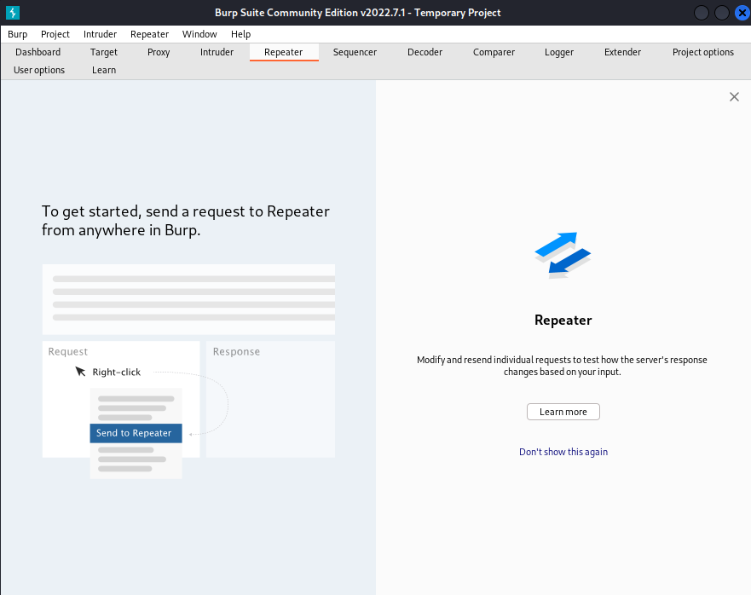

Step 11: We can send from HTTPserver Urls by right clicking on it and click on “Send to Intruder” or Ctrl+I.

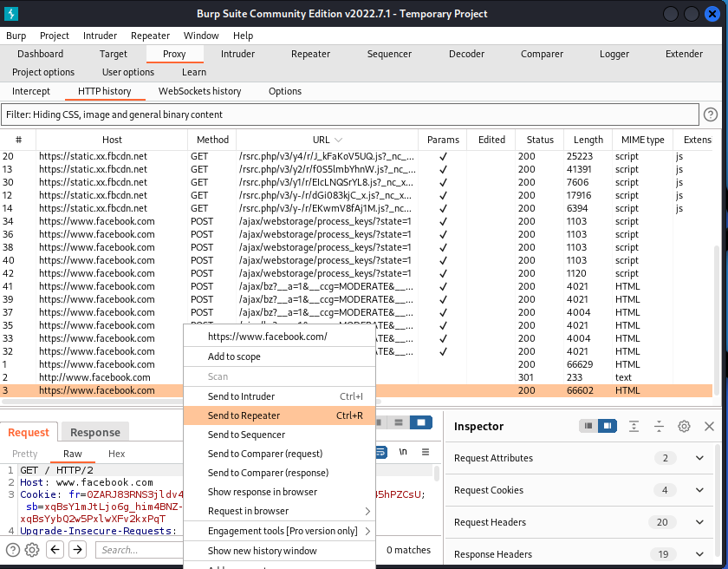

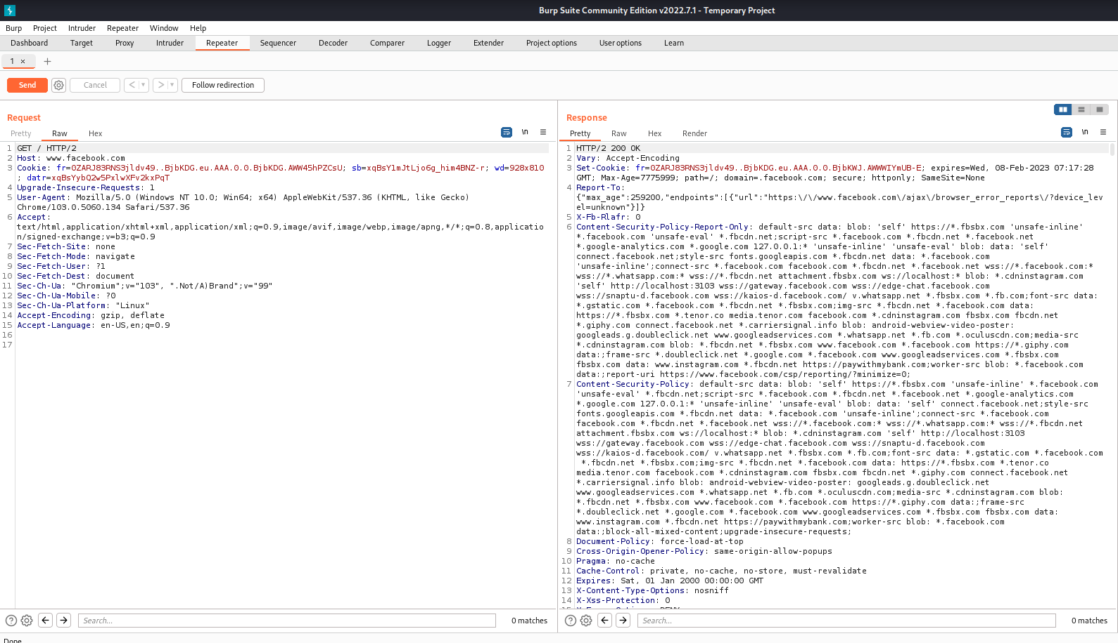

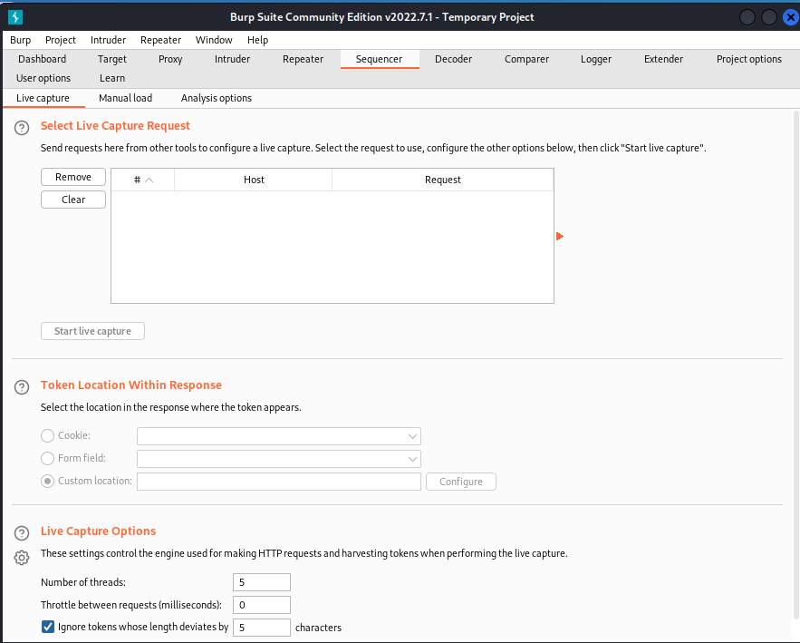

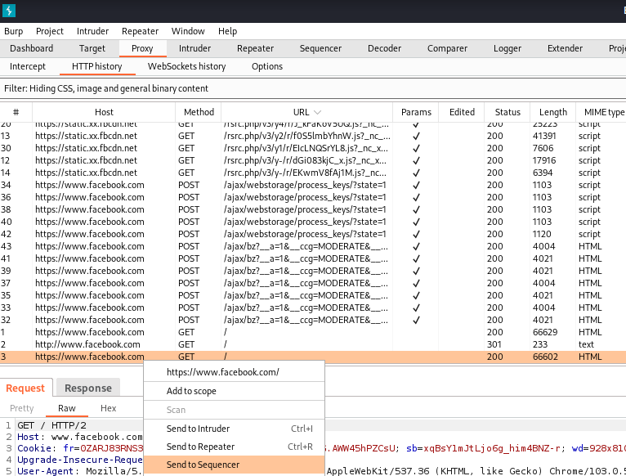

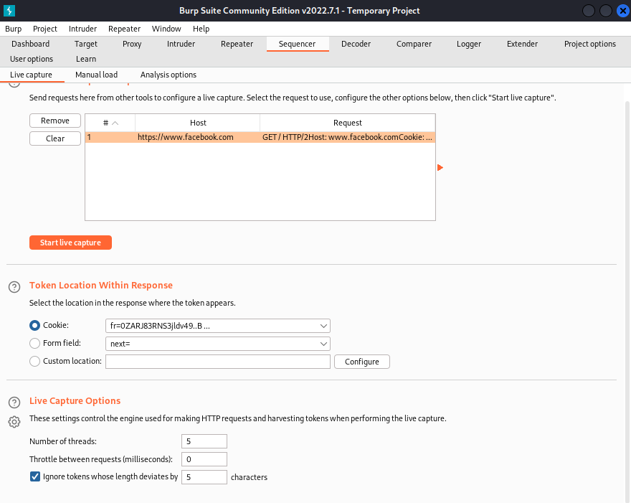

1. **Nikto**

Step 1: Insert Command> nikto

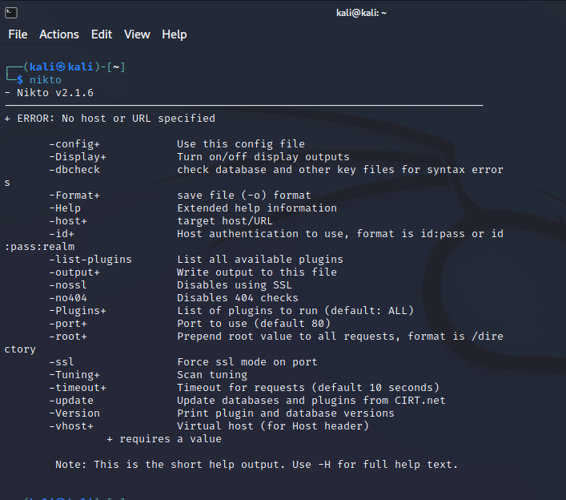

Step 2: Insert Command> ping [www.ajio.com](http://www.ajio.com) 🡪 nikto -h 116.50.83.240

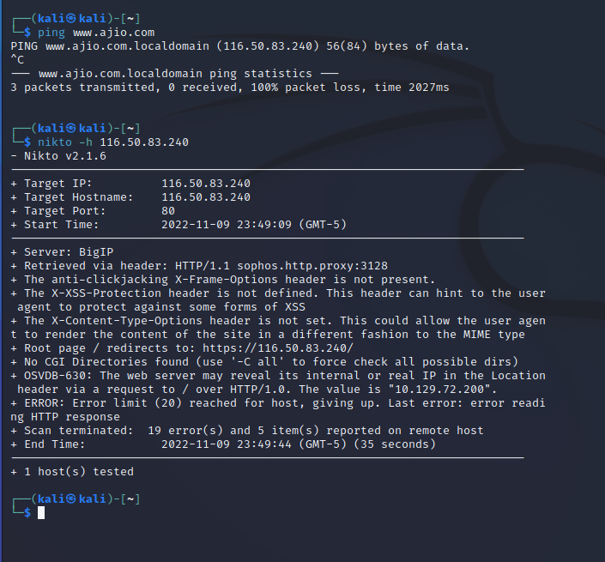

**PRACTICAL 9**

**(Client-Side Attacks)**

1. **HTA Attack**

Step 1: Open Kali Linux**>**Click on Applications>Social engineering tools

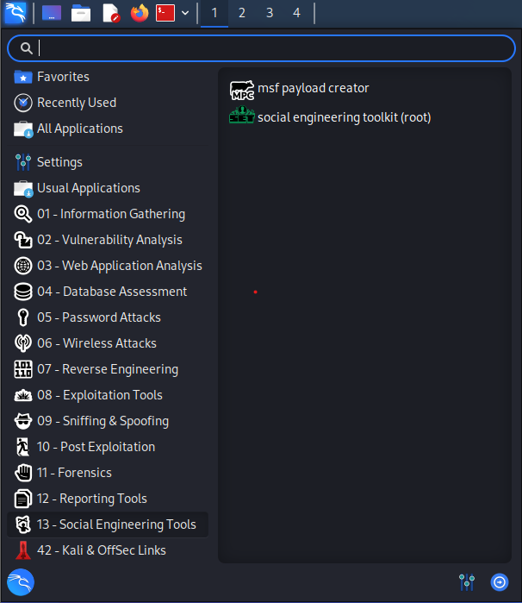

Step 2: Insert Command> Type "y”

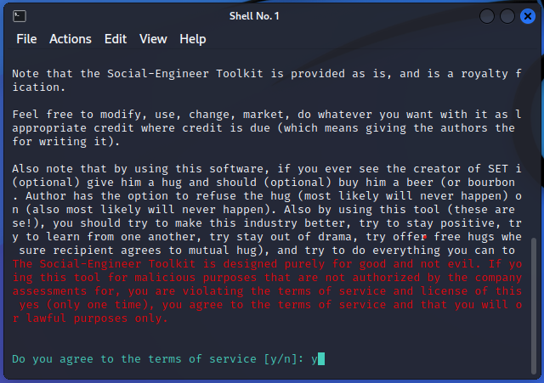

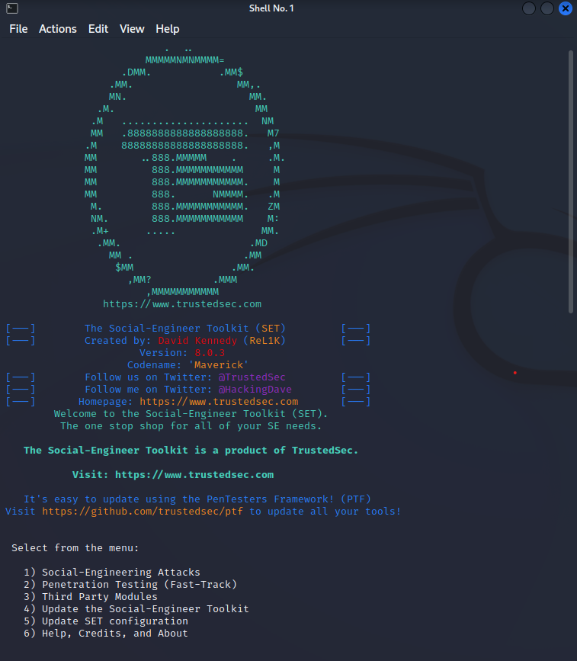

Step 3: Select webattack with respect to number.

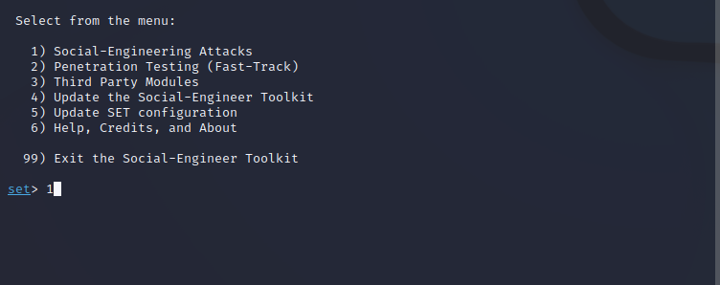

Step 4: Select “Website Attack Vectors”

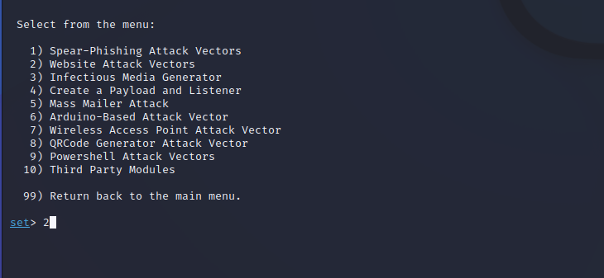

Step 5: Select “HTA Attack Method”

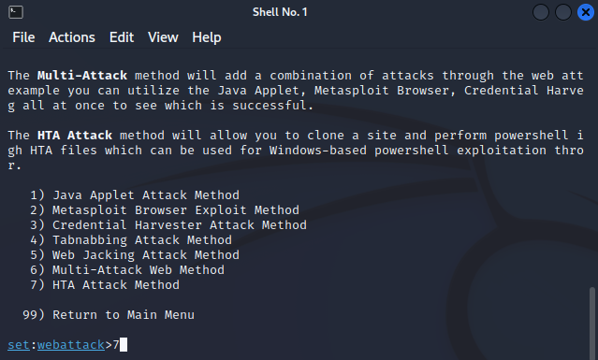

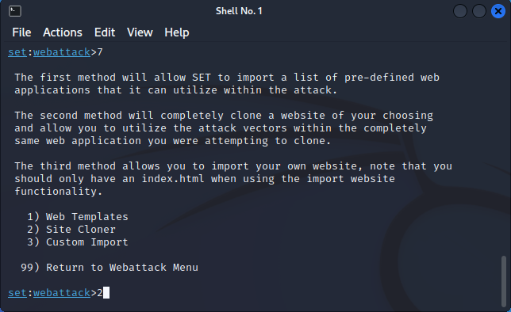

Step 6: Copy paste the website link in front of “url to clone”.

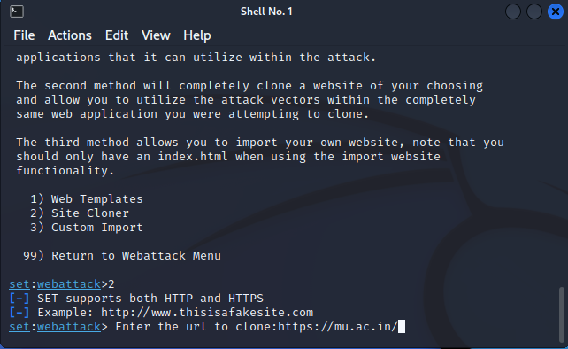

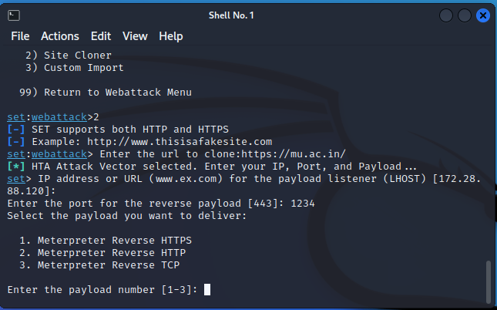

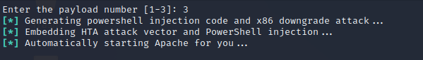

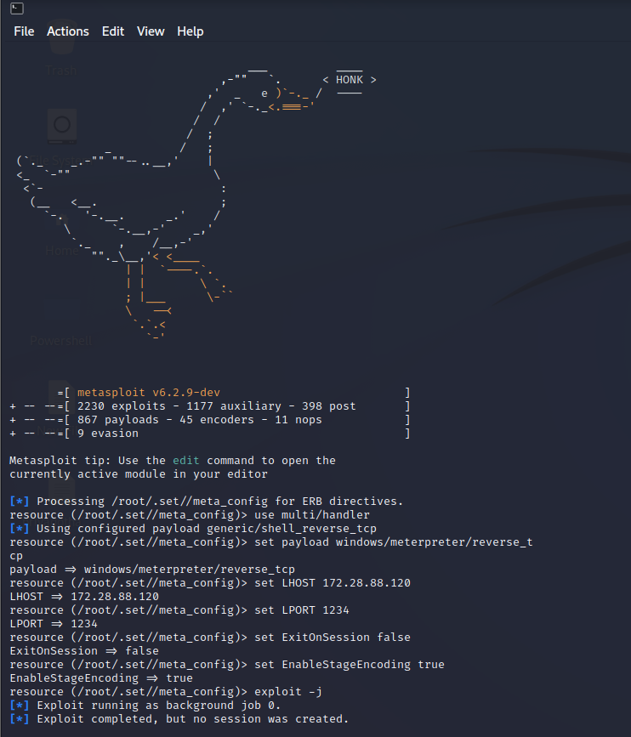



1. **Exploiting Microsoft Office**

Step 1: Install LibreOffice and John Ripper tool from the terminal.

Step 2: Insert Command> sudo apt install john

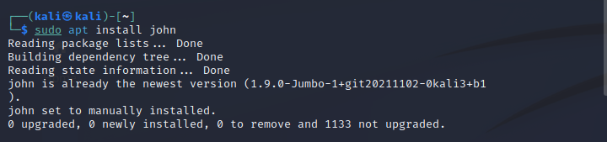

Step 3: Insert Command>sudo apt install libreoffice

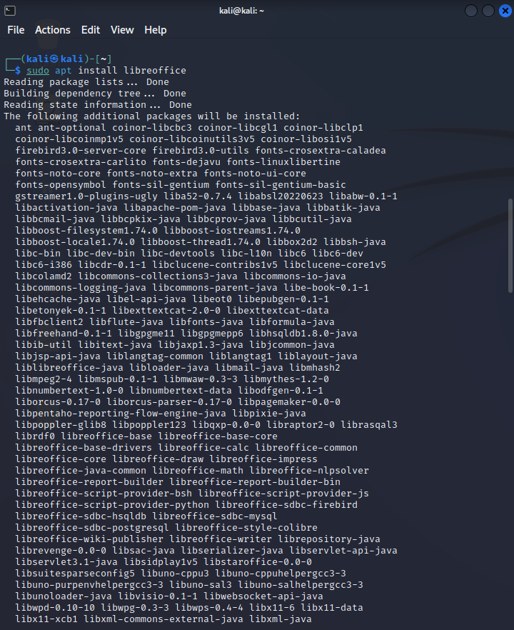

Step 4: Explore John Ripper tool using man john command: man john

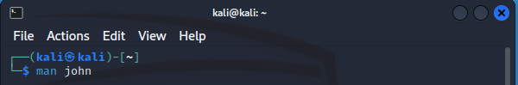

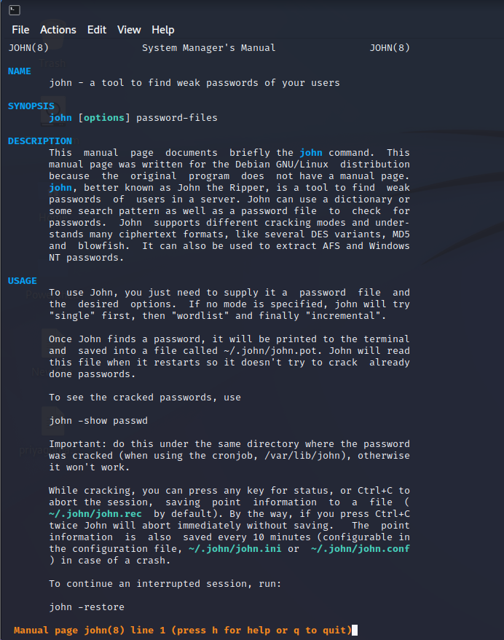

Now, Create & save a docx file in an password encrypted format. In the terminal, give the path of office2john.py file from john folder & also paste path of the path of the docx folder which you have created and give the access by creating any text file using the below command (eg. crack.txt).

Step 5: Insert Command> /usr/share/john/office2john.py /home/kali/Desktop/Target1.docx > crack.txt

Step 6: Insert Command> cat crack.txt

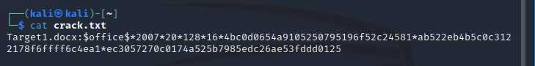Using the help command, we will get a command for cracking the password of the docx file.

Step 7: Insert Command> john -- h

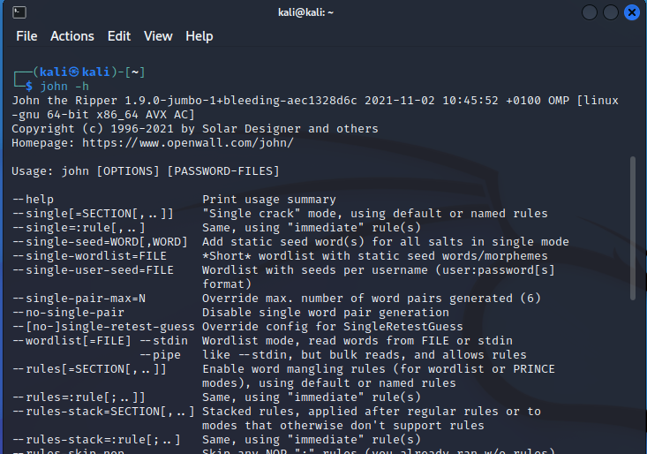

Crack the password using the length command. Here, we got the password which we cracked.

Step 8: Insert Command> john crack.txt – length=4

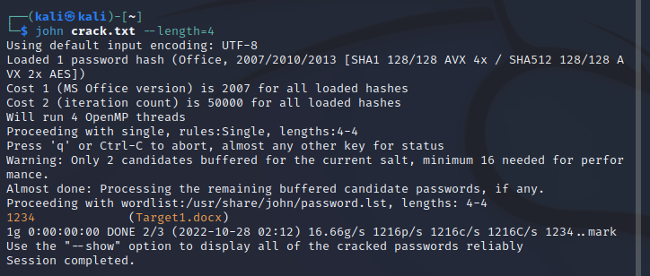

**PRACTICAL 10**

**(Password Attacks)**

1. **Wordlists, Brute Force Wordlists**

Step 1: Go to www.https://github.com/Mebus/cupp, Copy the URL from code section

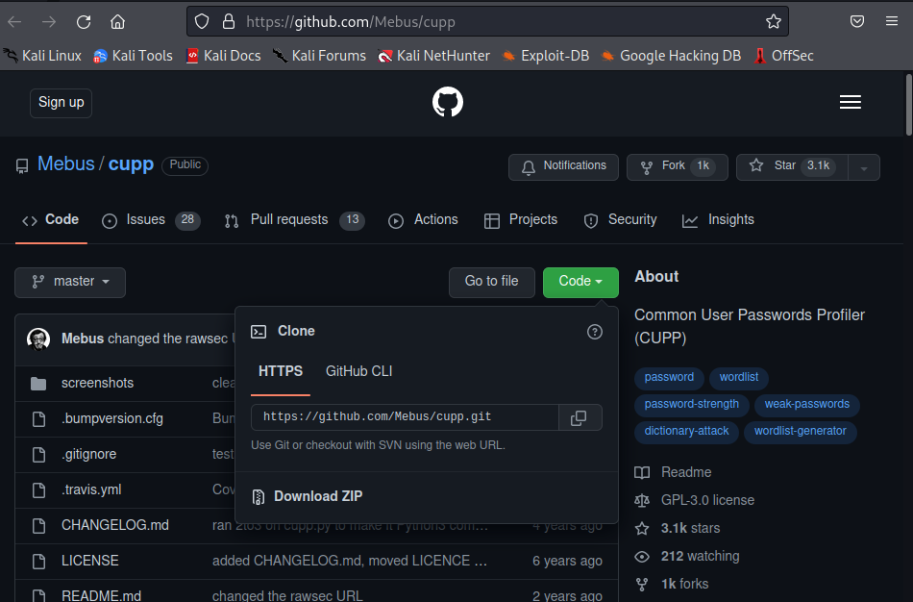

Step 2: Insert Command> cd Desktop

Step 3: Insert Command> git clone https://github.com/Mebus/cupp.git

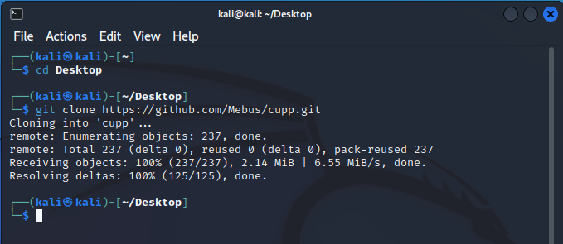

Step 4: Insert Command> cd cupp

Step 5: Insert Command> ls

Step 6: Insert Command> open the file cupp.py by writing the code “ ./cupp.py ”

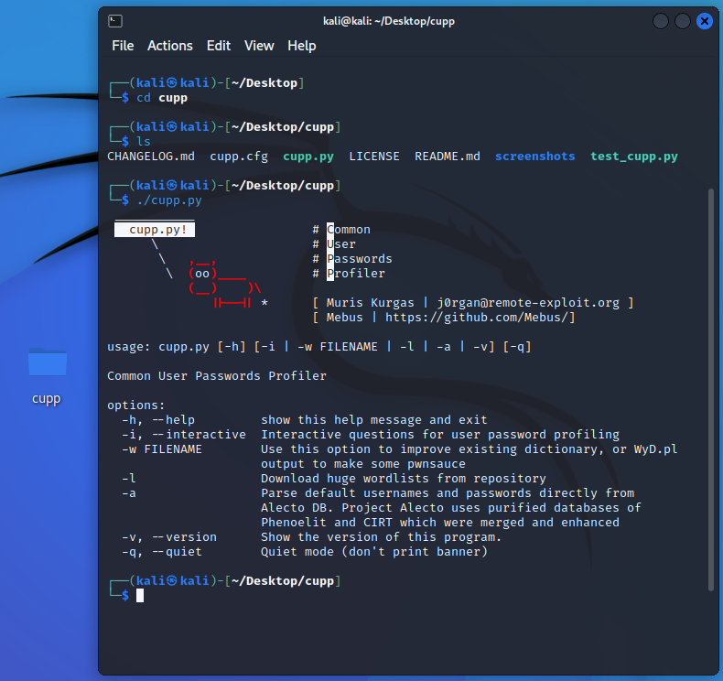

Step 7: Insert Command>./cupp.py -i

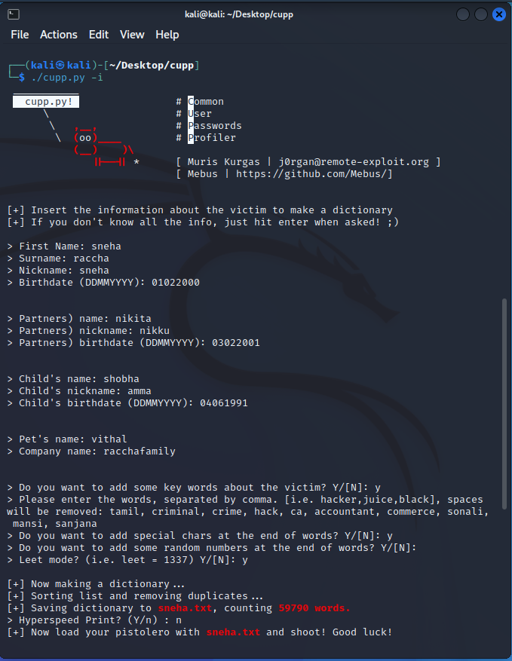

Step 8: After completing all details, “sneha.txt” is created with all possible configuration and sequence of words all containing details around 59790 words

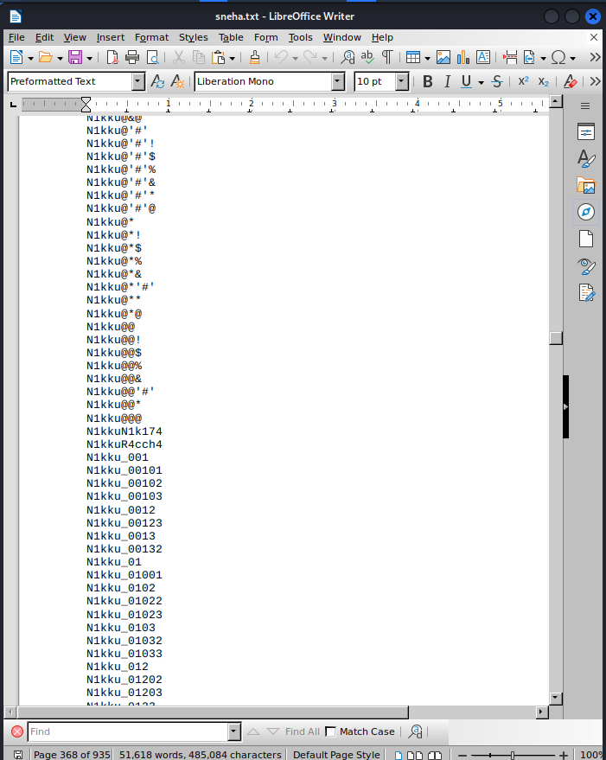

Step 9: Insert Command> leafpad

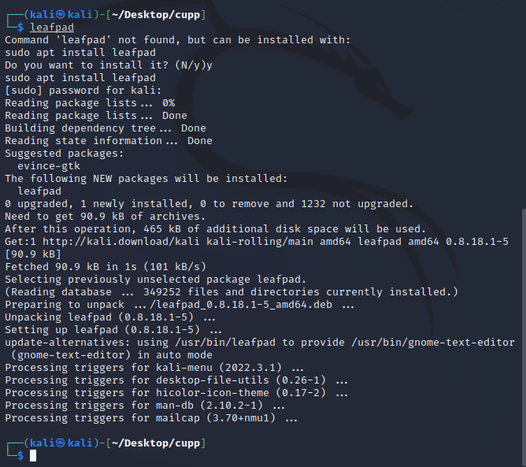

Step 10: Create a pass.txt file in Desktop with some data in it.

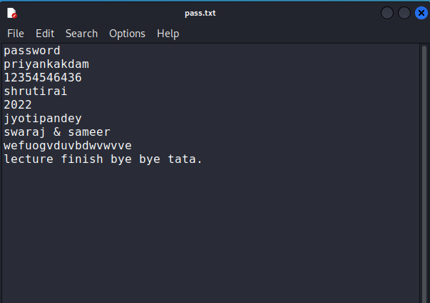

Step 11: Insert Command>./cupp.py –w /home/kali/Desktop/pass.txt

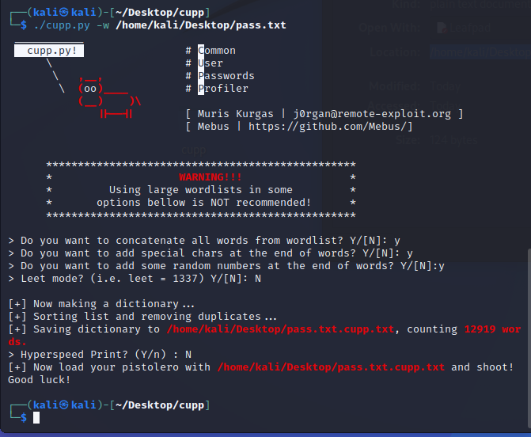

Step 12: Insert Command> It creates txt file in /home/kali/Desktop/pass.txt.cupp.txt with counting 12919 words in it.

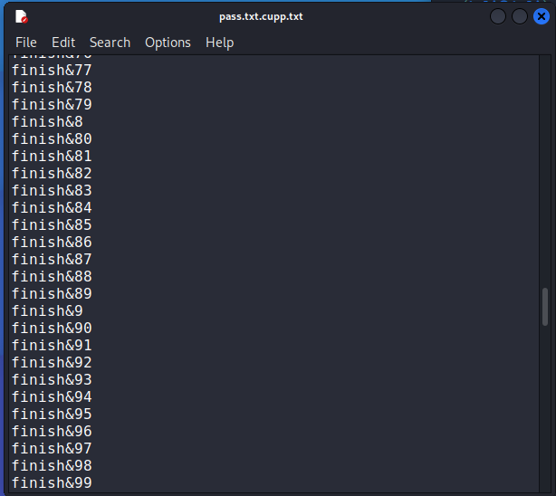

Step 13: Insert Command>./cupp.py -l

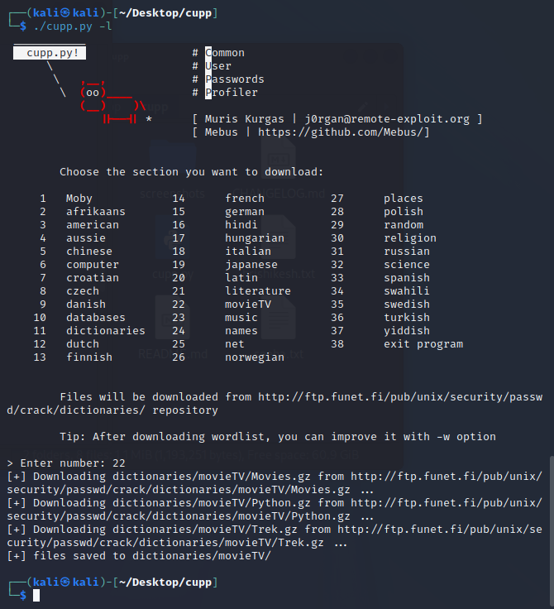

Step 14: When we enter number “22” , dictionaries were downloading from <http://ftp.funet.fi/pub/unix/security/passwd/crack/dictionaries/movieTV/Movies.gz> . We get data of “Movies.gz”, “Python.gz”, “Trek.gz”.

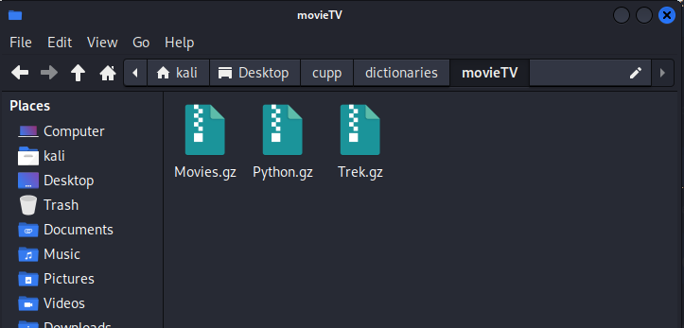

Step 15: Insert Command> Open “Movies.gz” file.

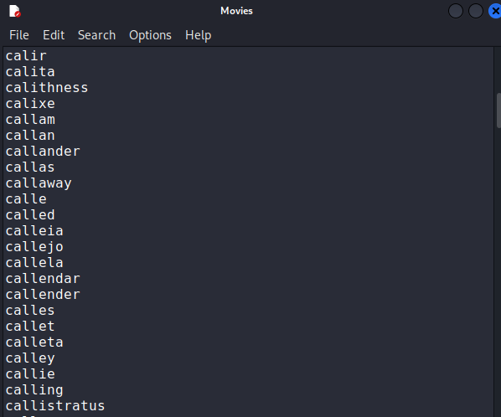

Step 16: Insert Command> Type command on terminal ./cupp.py -v

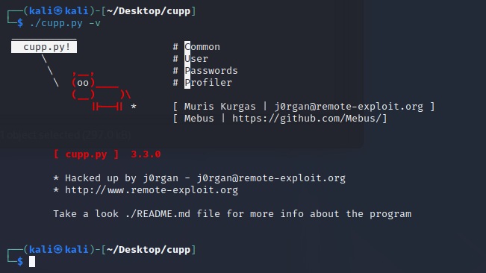

**Brute Force Wordlists**

Step 1: Insert Command> sudo su

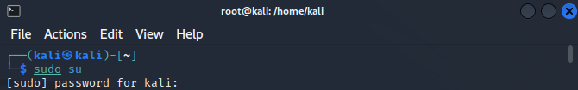

Step 2: Insert Command> crunch --h

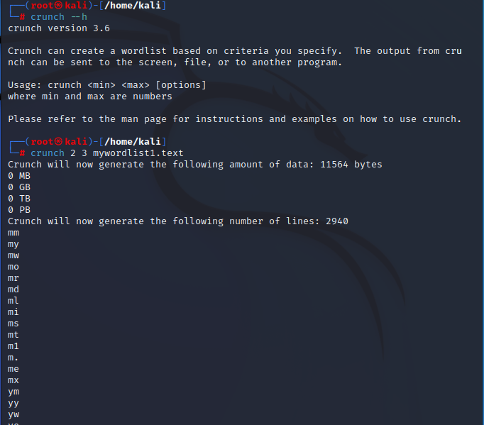

Step 3: Insert Command> crunch 5 6 angel

